

Practices for Secure Software Report

Table of Contents
Document Revision History 3
Client 3
Instructions 3
Developer 4
1. Algorithm Cipher 4
2. Certificate Generation 5
3. Deploy Cipher 5
4. Secure Communications 6
5. Secondary Testing 6
6. Functional Testing 7
7. Summary 8
8. Industry Standard Best Practices 8

Document Revision History

Version | Date | Author | Comments
1.0 | 10/12/2026 | Gavin Urba | Initial report

Client



Instructions

Submit this completed practices for secure software report. Replace the bracketed text with the relevant information. You must document your process for writing secure communications and refactoring code that complies with software security testing protocols.

- Respond to the steps outlined below and include your findings.
- Respond using your own words. You may also choose to include images or supporting materials. If you include them, make certain to insert them in all the relevant locations in the document.
- Refer to the Project Two Guidelines and Rubric for more detailed instructions about each section of the template.

Developer
Gavin Urba

Algorithm Cipher
As a web-based financial services company, secure communication is a top priority for Artemis Financial. Ensuring that customer data is genuine and has not been tampered with is a crucial aspect of securing their communication. One way of protecting the integrity of data is using checksum verification with cryptographic hash functions. For Artemis Financial in particular, recommend using the SHA-256 hashing algorithm, which is part of the Secure Hash Algorithm family. Developed by the National Security Agency (NSA) and published by the National Institute of Standards and Technology (NIST) in 2001, SHA-256 is a strong hashing algorithm which generates a unique hash value that acts as a digital fingerprint for a set of data (Encryption Consulting, 2024).
Unlike encryption, which uses random numbers and keys to protect data confidentiality, hashing verifies data integrity without concealing or encrypting the original information. In SHA, the data itself represents the “key” as even a small change to the original data produces an entirely different hash value. This is because SHA-256 produces its 256-bit hash value by splitting incoming data into 512-bit blocks and running each block through 64 rounds of transformations. At the end of this process, a 256-bit long value called a checksum is produced which serves as a mathematical summary of the data. By comparing the 256-bit hash produced before and after transit, checksum validation, SHA makes it easy to detect when data is tampered with or becomes corrupted.
Another important feature of SHA-256 is its ability to resist collisions. A collision occurs when two different sets of data produce the same hash value. Since SHA-256 produces a 256-bit long hash, the number of possible checksums are so large that finding two different inputs with the same checksum is computationally impractical. This makes SHA-256 a reliable option for checksum verification because it is highly unlikely that altered data will produce the same hash as the original data.
Hashing algorithms have evolved over time as advances in computing have revealed weaknesses in older methods. MD5 and SHA-1 were once commonly used to verify data integrity, but both have known collision vulnerabilities that make them unsuitable for security-sensitive applications (Madan, 2023). SHA-256 was introduced as part of the SHA-2 family to provide stronger security. Today, SHA-256 is regarded as the industry standard for strong cryptographic hashing and continues to provide security and trustworthiness to many channels of communication on the internet.
For Artemis Financial, SHA-256 would provide a practical way to detect changes to financial information exchanged through its web application. However, checksum verification alone cannot guarantee that data has not been maliciously altered. An attacker could change both the data and its checksum, causing the values to match. To provide stronger protection, Artemis Financial should use SHA-256 alongside secure communication protocols such as HTTPS with Transport Layer Security (TLS) and digital signatures. Together, these measures would help protect the integrity and security of Artemis Financial’s communications.

Certificate Generation
Insert a screenshot below of the CER file.
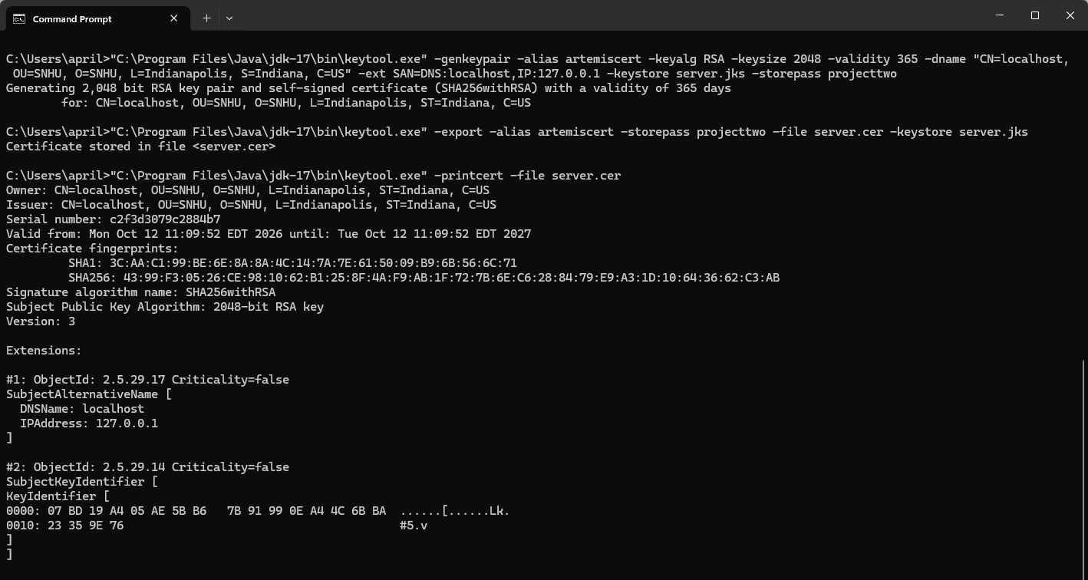

Deploy Cipher
Insert a screenshot below of the checksum verification.
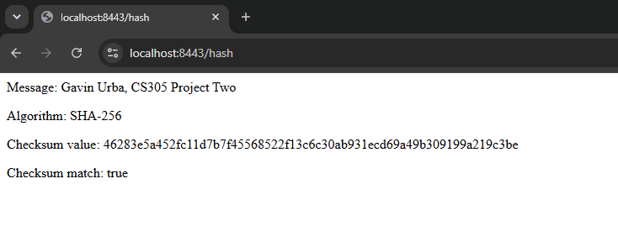

Secure Communications
Insert a screenshot below of the web browser that shows a secure webpage.
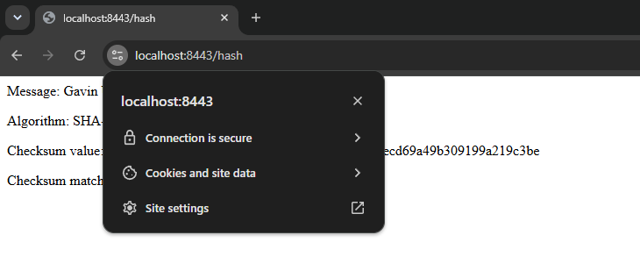

Secondary Testing
Insert screenshots below of the refactored code executed without errors and the dependency-check report.
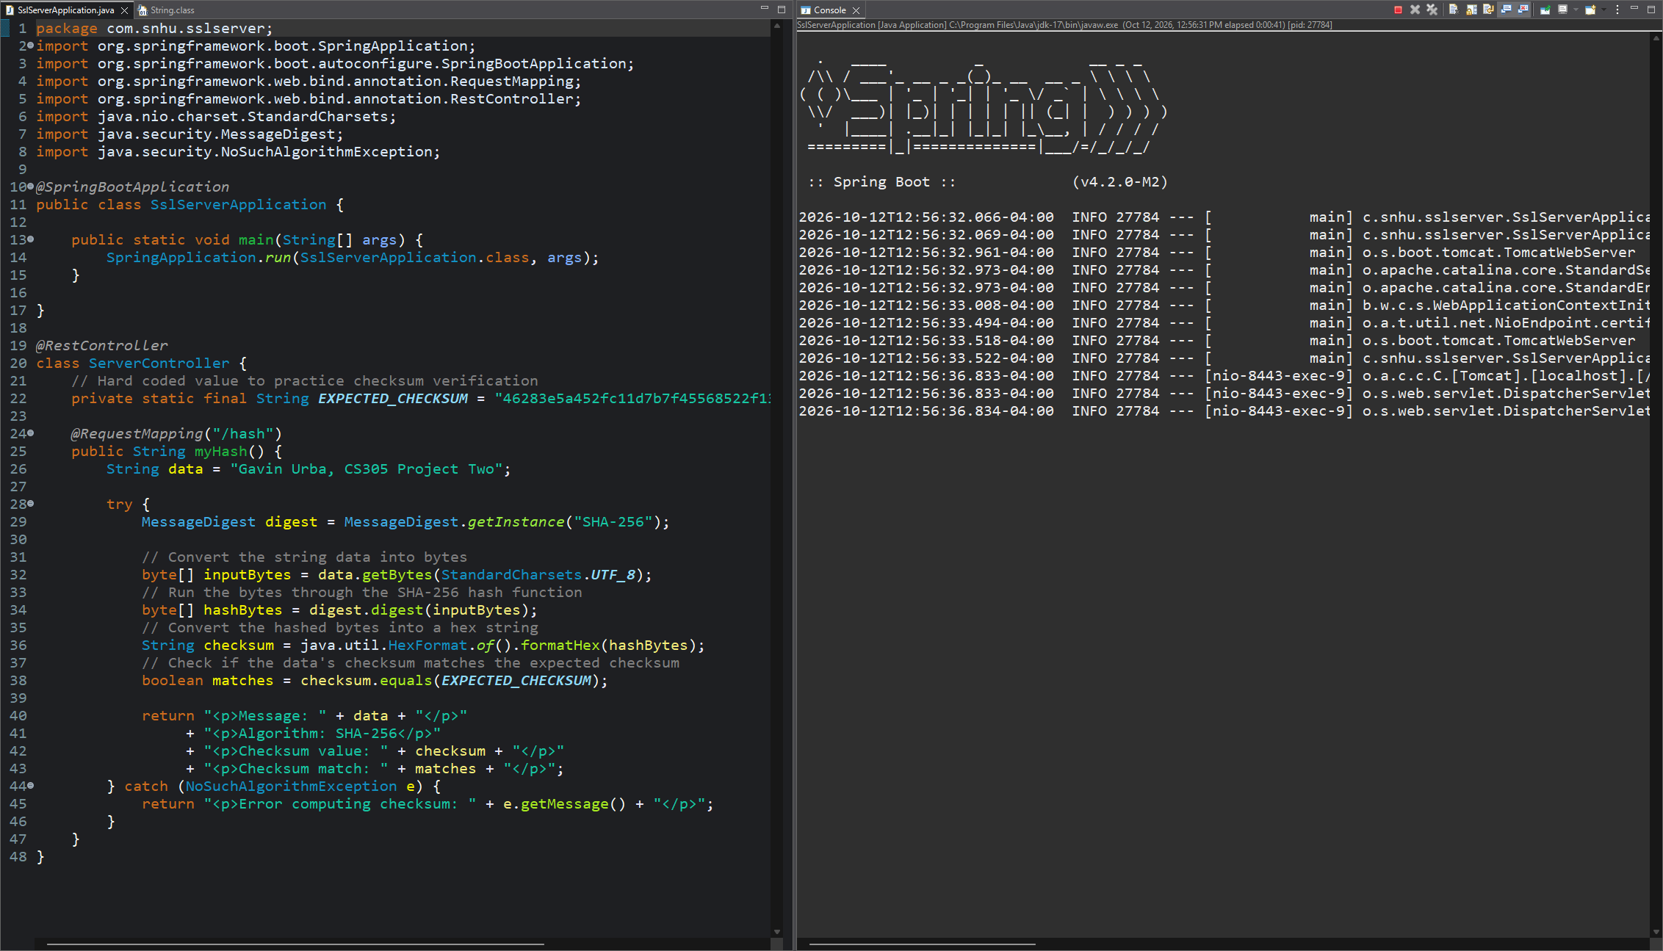
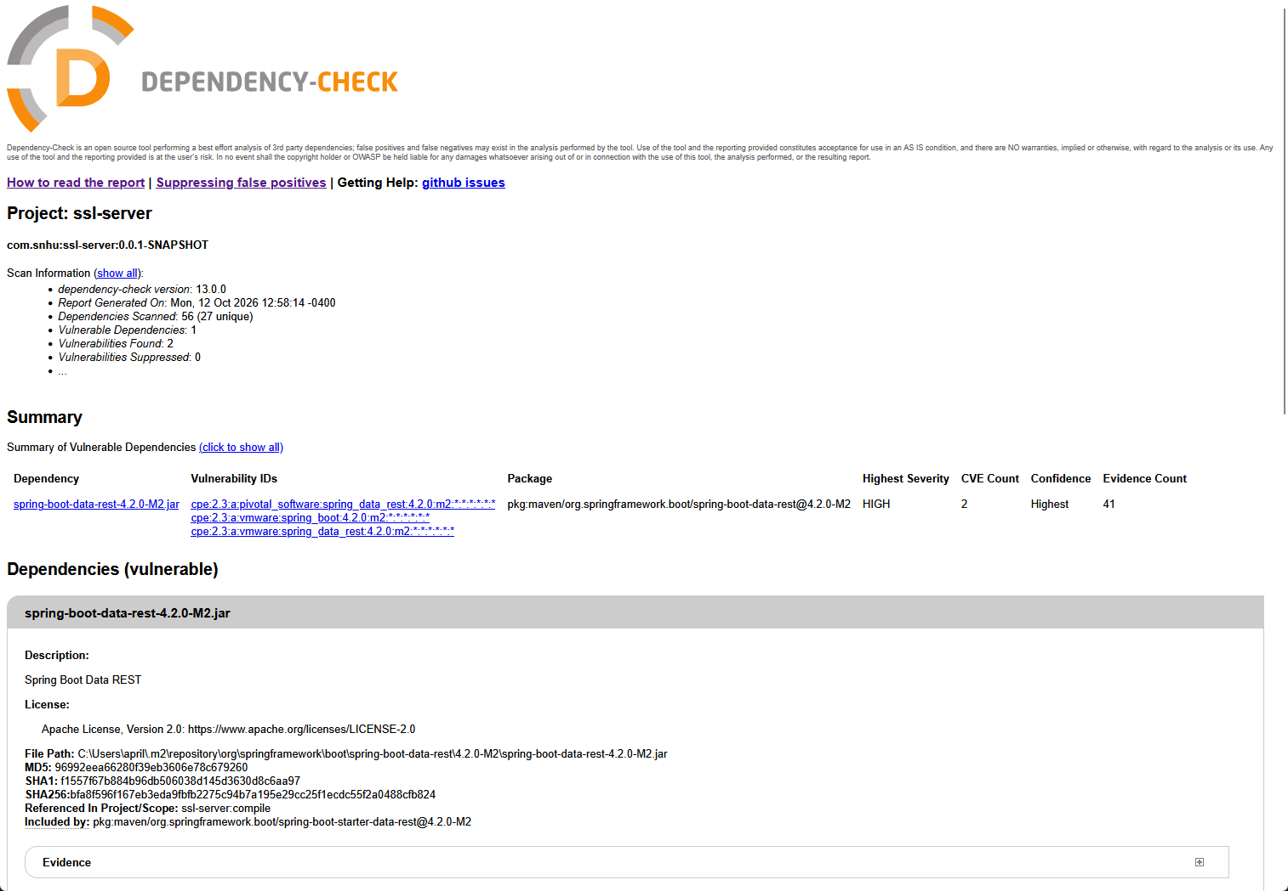

Functional Testing
Insert a screenshot below of the refactored code executed without errors.
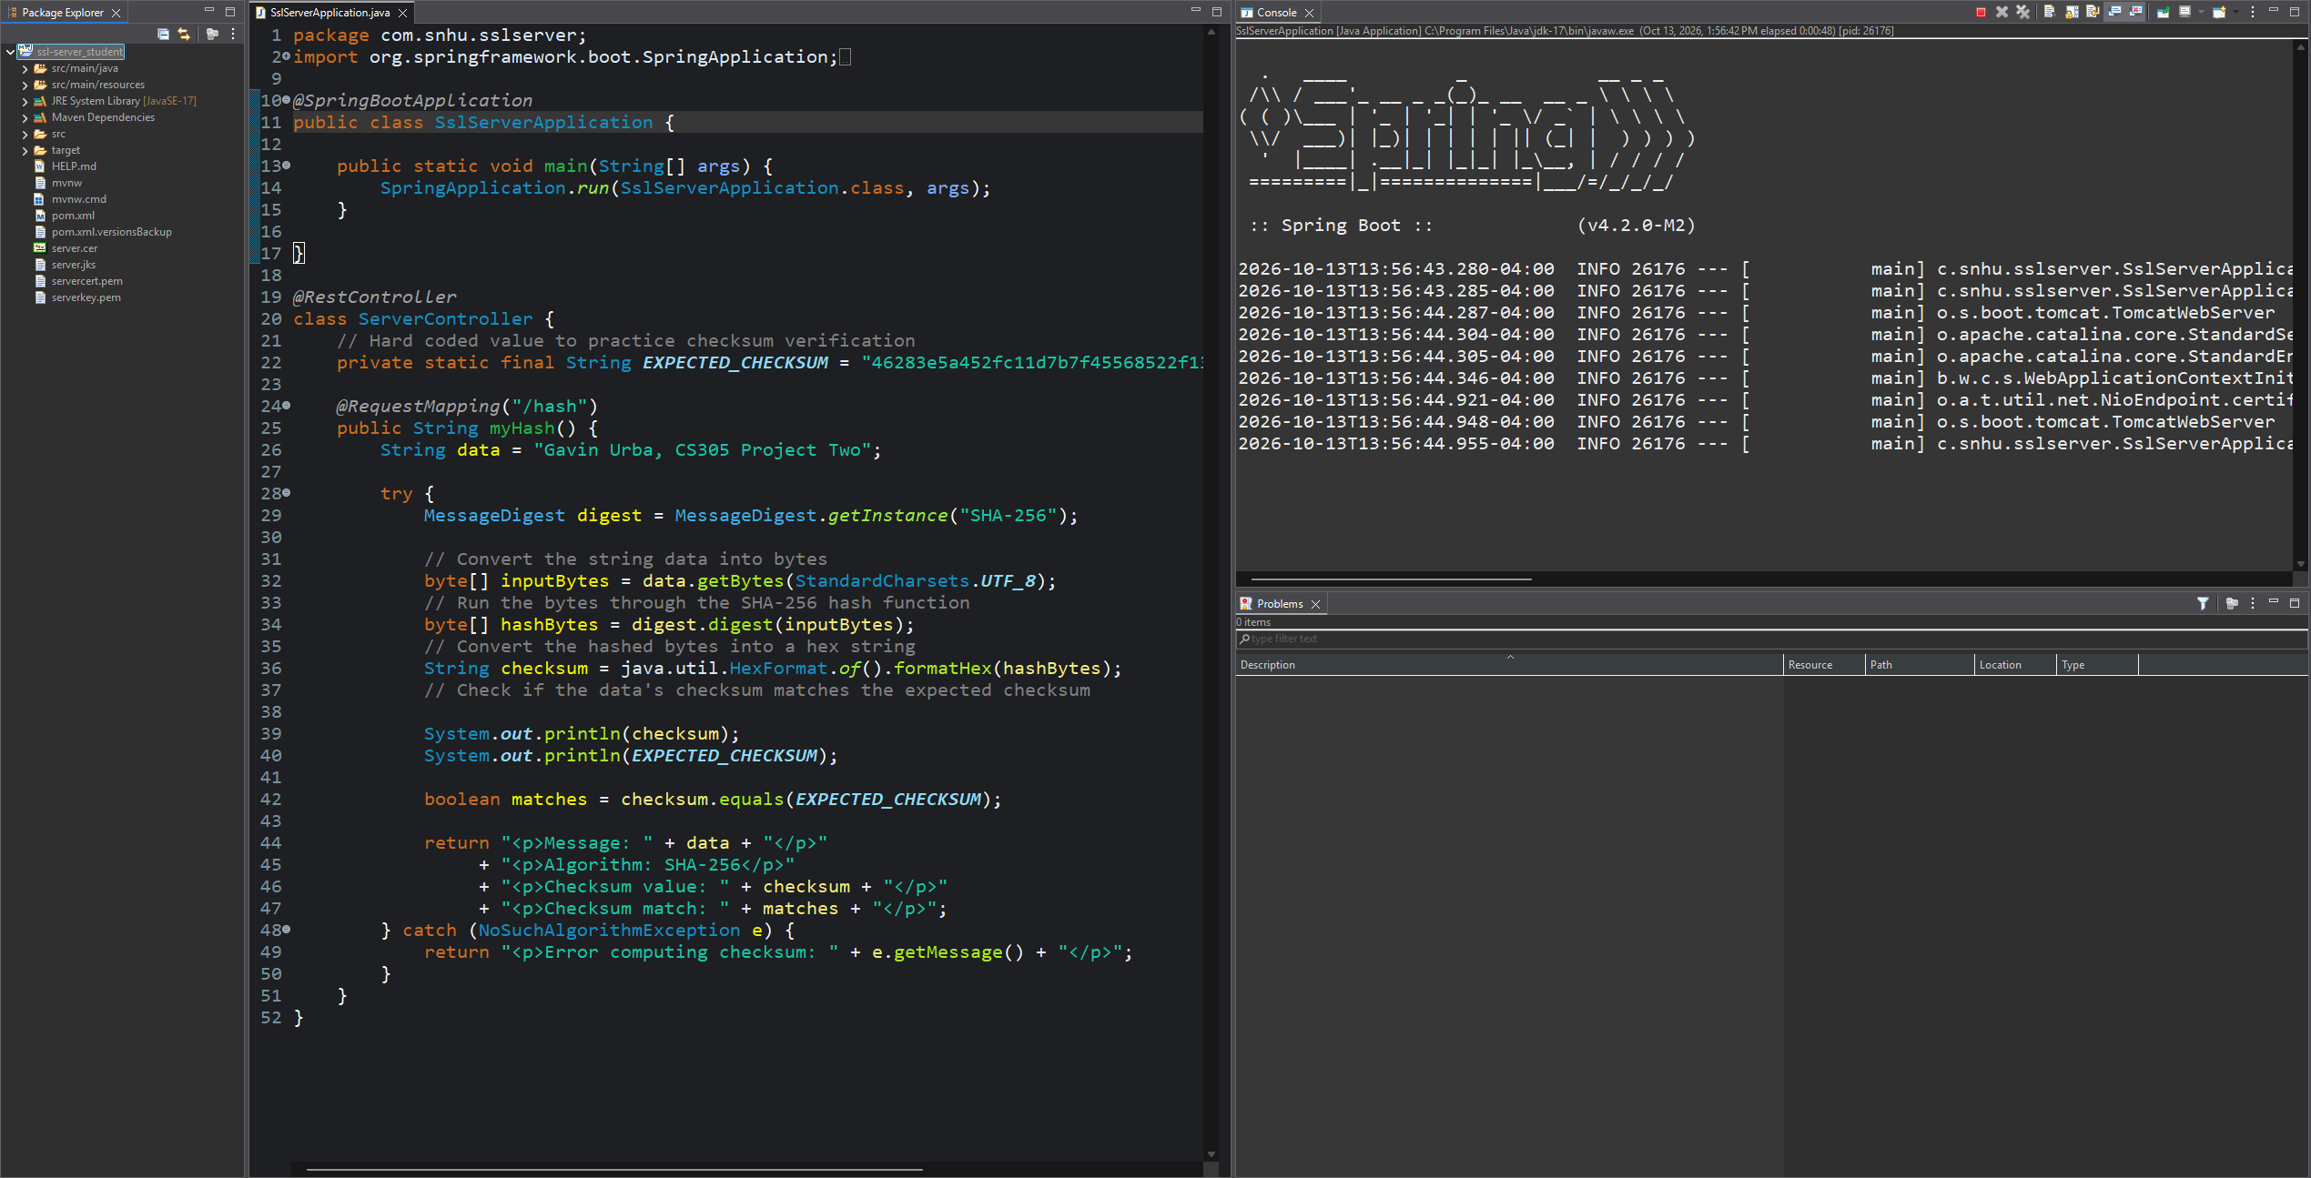

Summary

Following the vulnerability assessment process helps identify areas where additional protections may be needed and supports a layered approach to application security. The codebase was refactored to address several areas of security, including API interactions, cryptography, error handling, and code quality. Most notably, a new “/hash” endpoint was added to SslServerApplication to demonstrate SHA-256-based checksum validation. This endpoint shows how cryptographic hashing can help detect changes to data and support data integrity verification. To further protect client-server communications, a self-signed certificate was generated, and the application was configured to use HTTPS. These changes introduce multiple layers of security by addressing data integrity and communication security. Although they do not eliminate every potential vulnerability, they provide a foundation for additional security measures and future improvements as the application evolves.

Industry Standard Best Practices

Industry-standard secure coding practices were applied by updating the project to Java 17 and upgrading its dependencies to more modern versions. These updates reduced the number of vulnerabilities reported by the dependency-check tool from 168 to 2. Updating outdated software helps address known security weaknesses and reduces the risk of attackers exploiting vulnerable components. Additionally, the new SHA-256 checksum validation endpoint follows established cryptographic practices to demonstrate how data integrity can be verified. Together, these changes help maintain the application’s existing security while reducing its exposure to known vulnerabilities.
Applying industry-standard secure coding practices is important to Artemis Financial’s overall well-being because the company handles sensitive financial information that must be protected from unauthorized access and tampering. Reducing known vulnerabilities helps lower the risk of security incidents, data breaches, and potential financial losses. Maintaining updated software and dependencies also supports long-term security by making it easier to address newly discovered vulnerabilities as they arise. These practices help protect customer information, maintain trust in the company’s services, and reduce the potential financial and reputational damage associated with a security breach.

References

Encryption Consulting. (2024, March 4). What is SHA- 256? | Encryption consulting. Encryption Consulting. https://www.encryptionconsulting.com/education-center/sha-256/

Madan. (2023, August 30). A Deep Dive into SHA-256: Working Principles and Applications. Medium. https://medium.com/@madan_nv/a-deep-dive-into-sha-256-working-principles-and-applications-a38cccc390d4

